**Following the Roads: Using GIS Applications to Examine Potential Artifact Smuggling Paths**

Jessica R. Robkin, M.A., RPA

University of Central Florida, Department of Anthropology

[jrrobkin@knights.ucf.edu](mailto:jrrobkin@knights.ucf.edu)

**SUMMARY**

The Middle East and North Africa (MENA) region has a long history of archeological site looting, both for subsistence purposes and during periods of political unrest. These activities have seen a dramatic upsurge with the rise of extremist groups – such as ISIS – as well as state actors, motivated by increasing investor pressure from black market players looking to profit from the looting of cultural heritage in destabilized regions. The increased demand of illicit antiquities from the region must be met with viable methods of identifying routes these groups may use when transporting stolen artifacts into the realm of the black market. The trade of these resources not only lines the pockets of criminals but results in a tragic loss of archaeological and cultural knowledge that is fundamental to understanding the past and helping create lasting stability in the region.

Using maps created from satellite imagery from Iraq and Syria, this project makes use of the extensive road network within both countries to examine the potential paths that looters could take from archaeological sites to various avenues out of the region, or to locations that could provide options for long-term storage in safe havens. GIS applications repeatedly prove beneficial in the battle against cultural heritage destruction and it is the goal of this research to combine the valuable tools within ArcGIS, such as Thiessen polygons, buffer analyst, and the Near function, to follow the roads and provide a useful analysis to aid this endeavor. With a focus on the ISIS insurgency of Iraq in 2014, research into the vehicles used by this organization has been combined with the above-mentioned ArcGIS functions to demonstrate the value of these applications in three related scenarios based on utilizing the road network to transport illicit antiquities. It is my hope that this analysis will prove helpful for future research and for those who work to prevent the loss of cultural heritage associated with looting.

**BACKGROUND**

The Middle East has a long history of site looting (Daley 2018; Stone 2011, p. 34, 113, 163; Sorensen and Viejo-Rose 2015, 4; Viejo-Rose and Sorensen. 2015, p. 281-283). In the past, looting was carried out by opportunistic gangs of criminals and subsistence looters. While more recent examples of this include the looting of the National Museum of Baghdad following the withdrawal of troops after the U.S. led invasion of Iraq in 2003, the looting and destruction of the Cairo museum and unprotected archaeological sites across the country in Egypt following the Arab Spring Revolution in 2011, and the early looting by ISIS at the beginning of the Syrian Civil War, it is important to note that in some of the above instances, museum and heritage professionals were able to safeguard a number of artifacts prior to the violence and looting (Brodie & Renfrew 2005, p. 345-346; Parcak 2015). However, as ISIS became more powerful in the region, their systematic destruction of cultural heritage locations including the Mosul Museum, Nimrud, Hatra, Khorsabad, and Palmyra, have taken a more directed and organized turn (Terrill 2017, p. 4-20). The destruction of these sites has caused both internal and international outcry over the damage done to these world heritage locations. ISIS claims ideology as a motivator, but attacks on heritage sites have multiple purposes. While using site destruction for propaganda opportunities, they also loot the sites to sell antiquities on the black market to further fund their activities (Terrill 2017, p. 18-19, 25).

Understandably, the need to protect these sites is often superseded by the need to protect human lives and economic resources (Meskell 2014, p. 219; Terrill 2017, p. 28). Personnel and funding are stretched thin, and in regions with thousands of vulnerable sites, understanding the possible exit routes looters could exploit would be beneficial to overstretched governments and heritage workers in the region. GIS applications have been applied to the problem of looting in conflict zones in several recent projects, including the work done by Jesse Casana, Mike Danti, and Elizabeth Stone working in conjunction with the American Schools of Oriental Research’s Syrian Heritage Initiative (SHI) and Cultural Heritage Initiatives (CHI) (Casana 2015, Danti 2015, Stone 2015). The use of satellite imagery to better understand the damage done to heritage sites across the Middle East and North Africa (MENA) is becoming increasingly useful, and additional GIS applications can aid in appreciating how the extensive road networks throughout the region can provide a variety of options for the transport of looted artifacts either out of the region or into safe havens to be stored for future sale. Using GIS distance buffers in conjunction with information on the vehicles commonly used by insurgent groups – for this report, ISIS during the 2014 insurgency, specifically – can allow researchers to identify the likely paths that could be accessed and used to transport illicit antiquities. In theory, this could be combined with researching available satellite imagery taken after heritage sites have been attacked and looted, allowing us to follow the roads and possibly have a less muddled picture of the paths smugglers could likely take.

For this project, the following research questions will be explored:

1. Can GIS software applications aid in estimating locations that insurgents or gangs of smugglers could transport stolen heritage artifacts to?
2. How useful are knowing the road networks in understanding the possible paths that stolen artifacts could take out of the country?
3. How can knowing the capabilities of the vehicles used by insurgent groups aid in predicting possible exit routes?

These questions are designed with the specific purpose of showing the validity of using road networks to examine potential routes taken by smugglers, as well as to prove how valuable this information can be in conjunction with a thorough understanding of the tools used by those that would not only destroy cultural heritage locations but loot their artifacts for nefarious reasons. To do this, a series of three scenarios will be analyzed using GIS software applications and the findings will be discussed. Finally, suggestions will be made as to additional applications of these ideas, along with suggestions about possible next steps which could further enrich the analysis.

**METHODOLOGY**

The original project design called for using raster math applications, buffers, and least cost pathway tools to assign risk factors to the areas surrounding archaeological sites in the MENA region, specifically Iraq, as it seemed acquiring materials for Iraq would be less challenging than for other countries in the region. The risk factors initially suggested included those that would make it easier to transport illicit antiquities from archaeological sites either out of the country or to black market-friendly cities for storage. A daunting task, to be sure, especially given the lack of faith that predictive models can hold. Predictive models can be unreliable and easily picked apart, and so other options have been considered for this project, though some of the basic elements of the initial design have been retained. For the scope of this project, I have instead decided to follow the road systems within Iraq and Syria to shed light on the ease of which objects can be transported away from looted sites.

It is the goal of this project to produce a viable analysis of this road network for smuggling which can both be ground-truthed during times of greater political stability and be observed using satellite imagery. I still employ the use of buffers, though the use of least cost paths has been replaced instead with the use of Thiessen polygons and the Near function tool available within Esri ArcGIS software. Thiessen polygons and the Near function tool aided in identifying the paths that could viably be used by smugglers and insurgent groups looking to profit from the black-market antiquities trade. The buffer distances chosen have been designed to show ease of access to roads from archaeological sites, in the case of the 25 km buffers, and to explore how far known insurgent vehicles – the Ural 4320 6x6 off-road truck and the Oshkosh Medium Tactical Vehicle Replacement (MTVR) – can theoretically travel from looted sites with full fuel tanks. I chose these vehicles as research indicates that have both types have been reportedly stolen by ISIS from the Syrian and Iraqi armies (Illingworth, 2018; Leviev, 2016; Malcom, 2016). Additional research would supply carrying capacities and ranges for both – the Ural 4320 has an off-road carrying capacity of 6.6 tons and a range of 1000 km (Military-Today.com, 2019), while the MTVR has an off-road carrying capacity of 7 tons and a range of 483 km (Oshkosh Defense, 2014) – which informed my decision on buffer distances to use.

Using ArcGIS online, I downloaded numerous files relating to both Syria and Iraq, looking for maps of road systems, border crossings, territorial control, airports, airfields, and archaeological sites. After sorting through the many files, I had originally decided to focus solely on the country of Iraq during the ISIS insurgency in 2014. Because ISIS held control of a large number of cities in the north (Woodrow Wilson Center, 2019), for several analyses, I realized the benefit of including shapefiles of the Syrian road network and airports and airfields within both countries. I believe that these analyses can elucidate the possible routes smugglers, looters, or insurgents could utilize for moving artifacts – from small, easily transported objects to large, heavy statues and artifacts – from archaeological sites both out of the country and to locations known to be friendly to the black-market antiquities trade, where objects could be stored until a future date. Using the available files on road maps, faction-controlled border crossings, and 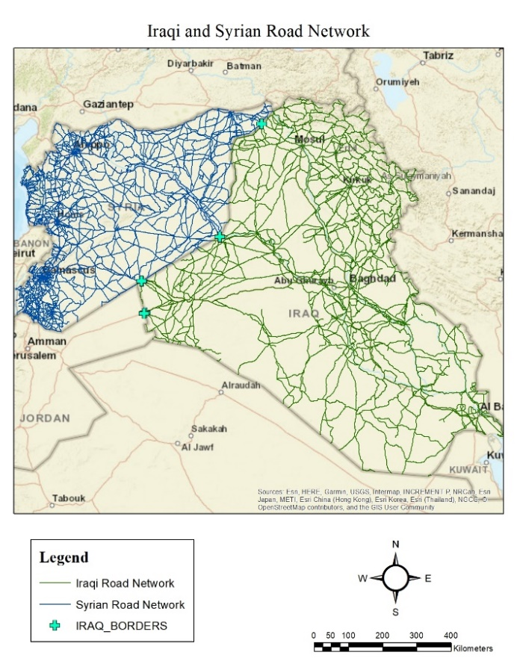territorial alliances allowed me to create maps of both Iraqi and the Syrian interior road networks (Figure 1). To these shapefiles, I added additional layers for known archaeological sites, border crossings, airports and airfields, and areas of territorial control (Figure 2) (ArcGIS Online Team, 2012; Digital Globe, 2018; mrhoades, 2018; nesforum, 2017; Sarah7600, 2014; Sarah7600, 2014; Sarah7600, 2014).

Figure 1: Iraqi and Syrian road network.

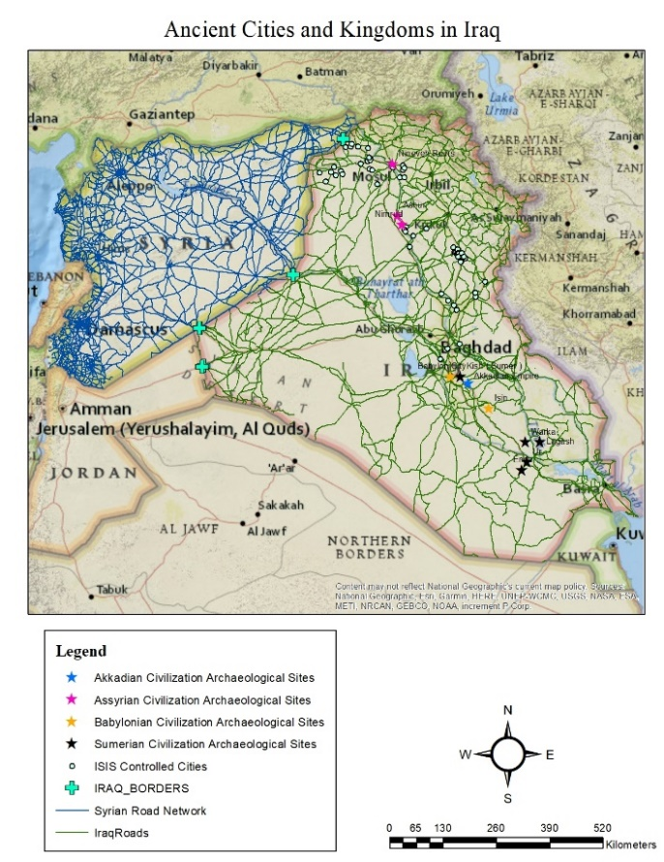Before starting my analysis, I used the Thiessen polygon function to study the possible range of control associated with the cities known to be under ISIS control in 2014 (Figure 3), as Thiessen polygons “define the area that is closest to each point relative to all other points” (Tchoukanski 2019). As can be seen in Figure 3, the coverage of ISIS control stretched across much of central and northern Iraq, encompassing access to ISIS controlled border crossings. With this as a starting point, my next step was to add in shapefiles containing defined road maps for Iraq dated to the same time period in 2014, as well as shapefiles containing locations for archaeological sites within the country. I then used the Near function to provide a base understanding of the distances between these 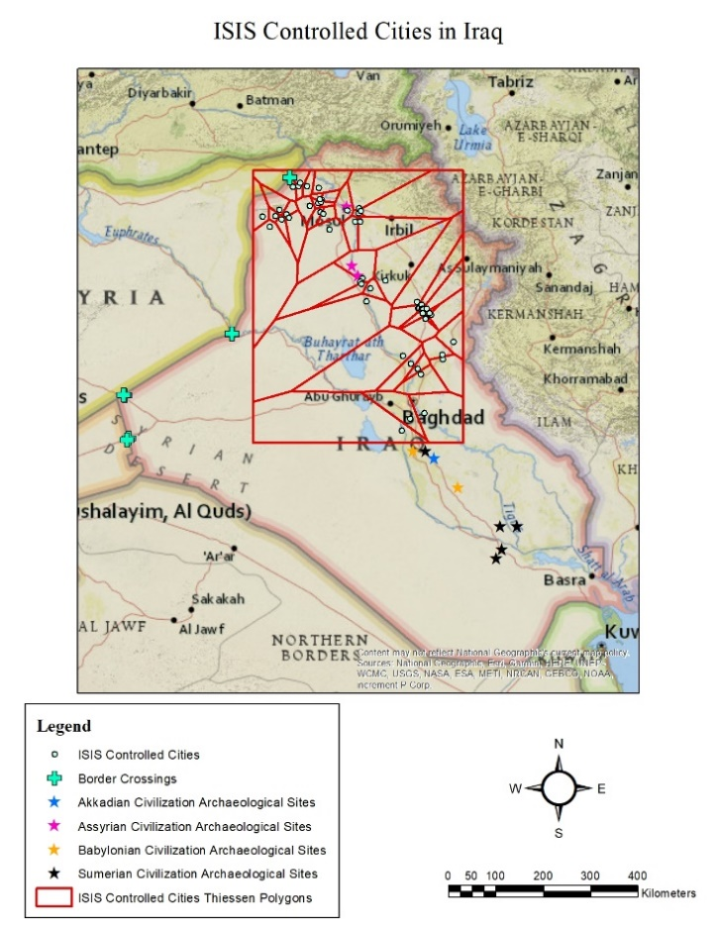archaeological sites and the closest viable roads and chose to run the buffer analyst to the closest road network. I decided to run a small 25 km buffer around the Assyrian Civilization archaeological sites – 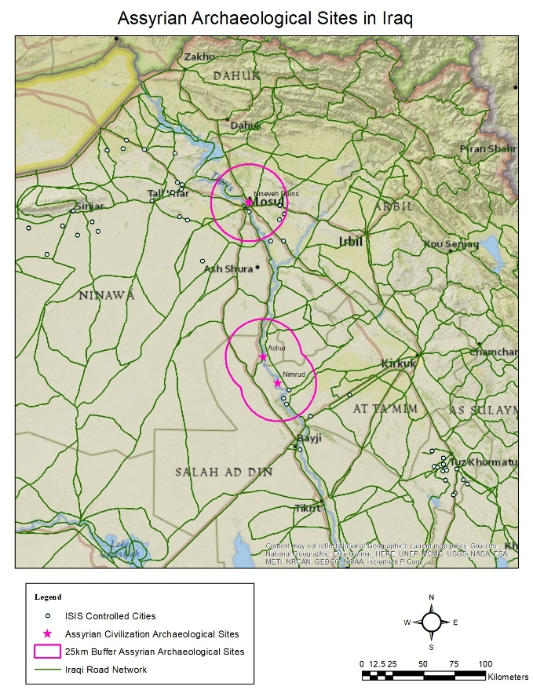those that fell within the Thiessen polygons of ISIS-controlled cities in the north – to see what options could be available to transport looted materials out of these locations. Running this buffer provided me with a clear picture of how easy it would be to loot a site and exit it via roads leading to ISIS-controlled borders and into possible safe havens or illicit trade networks (Figure 4). Given the shared border with Syria and the ISIS controlled border crossing into the country, it quickly became clear that I should also include a shapefile containing the known Syrian road networks (Figure 1).

Figure 2: Map of Iraqi archaeological sites, Syrian and Iraqi road networks, border crossings, and cities under ISIS control in 2014.

Figure 3: Map of ISIS controlled cities with Thiessen polygons.

Figure 4: Map of Assyrian archaeological sites with 25 km buffers

Once these shapefiles were combined and the analysis showed potential, I then researched the vehicles known to be used by ISIS and drafted three scenarios designed to better answer my research questions:

1. If ISIS is using Ural 4320 or the MTVR to transport large objects, or large collections of objects, how far can they move the goods on one tank of petrol?
2. With the capability of transporting medium- to large-sized objects, where would be likely points they could take the objects for further transport or storage?
3. Using the road networks within Iraq and Syria, where are the airports and/or seaports that could provide additional avenues of exporting looted artifacts?

**DISCUSSION**

Understanding the possible transport network available to smugglers provides useful information for further observation of these routes using satellite imagery. The buffer tools indicate that main roads pass close to a number of archaeological sites that could be at risk during times of political instability and/or insurgency. Following the roads both to archaeological sites and to border crossings and cities where looted objects, both large and small, could be stored for indeterminate periods of time, provides a tool that can be useful to not only identify the routes preferred by smugglers, but to also, possibly, identify and apprehend not only the smugglers themselves, but recover the artifacts they are moving.

The tools available within ArcGIS, with a heavy reliance on the buffer analyst tool, allowed me to run all three of the above scenarios, which provided answers to my research questions. My first two scenarios were created following research into the vehicles known to be used by ISIS, namely the Ural 4320 and the MTVR, while my third scenario was designed to complement the previous two and make use of the available maps from ArcGIS Online of the road networks in both countries. Knowing that smaller objects are easier to move, I focused on medium to large objects for much of my analysis. As there is no set definition of artifact size, I estimated that medium artifacts would be anything larger than what one could fit into a pocket or a backpack, while large objects could reach a weight of up to 6 tons. Of course, insurgent groups – or well-equipped looting gangs with similarly capable vehicles – could viably transport a combination of medium to large artifacts, as opposed to just one or two large objects.

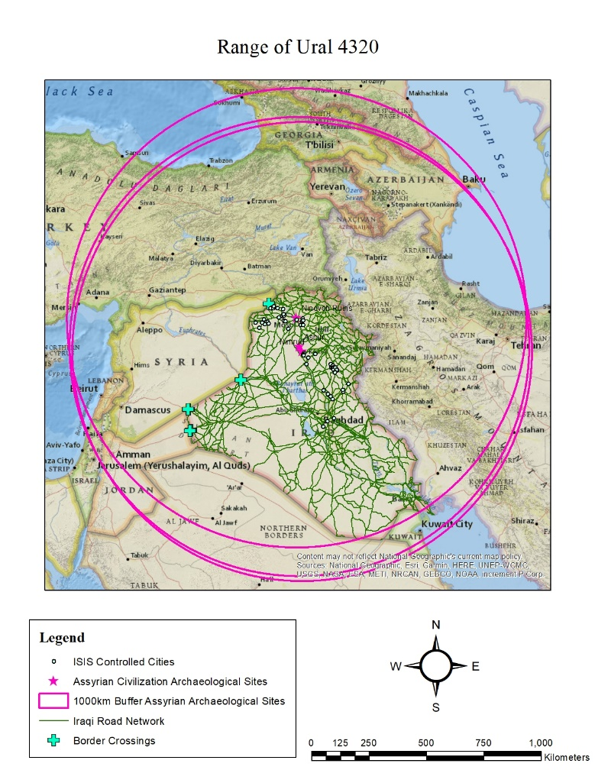**Scenario 1: If ISIS is using the Ural 4320 or the MTVR to transport large objects, or large collections of objects, how far can they move the goods on one tank of petrol?**

The Ural 4320 has fuel tank capacity of 300 litres and a range of 1000 km. This is a considerable distance, allowing smugglers to take advantage of the extensive road network and the off-road capabilities of the vehicle to easily leave the country, traveling through not only most of the faction-controlled border crossings from Iraq to Syria, but also from Syria into Turkey – a well-known safe haven for moving antiquities from these areas (Terrill 2017, p. 20) (Figure 5). Additionally, if ISIS – or other groups of opportunistic looters, or the governments themselves – is using other known military vehicles, such as the MTVR, which has a much more limited range of 483 km (Oshkosh Defense, 2014) they still have capabilities to reach airports/fields, black market-friendly cities or seaports, or to exit Iraq.

Figure 5: Map of range of Ural 4320

**Scenario 2: With the capability of transporting medium- to large-sized objects off-road, where could they likely take the objects for further transport or storage?**

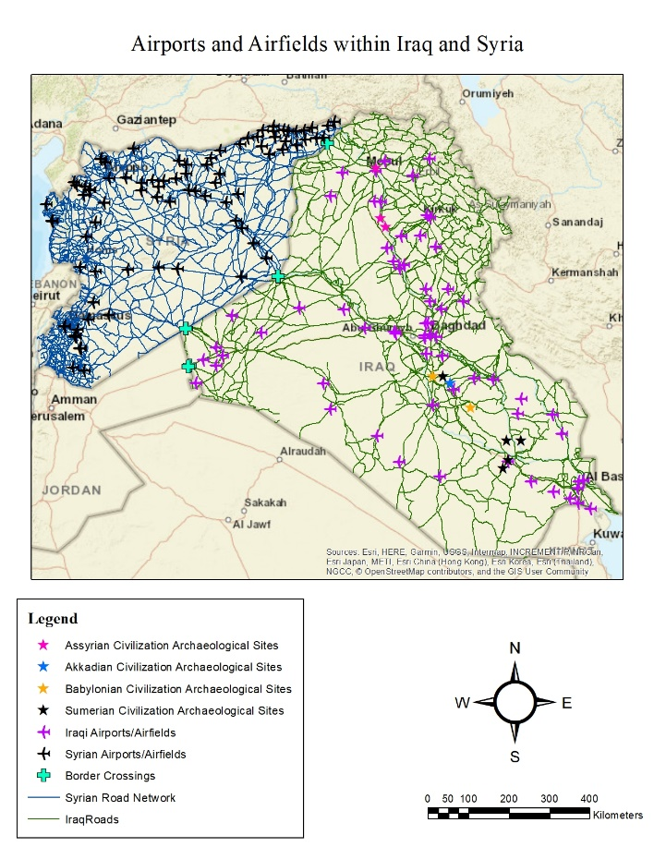The impressive 1000 km range of the Ural 4320 allows for an extremely large area of possibilities. Smuggled artifacts could, in theory be taken to almost any airfield or airport within both Syria and Iraq (Figure 6), as well as to ports in both countries. In the north of Iraq, where ISIS held control numerous cities (Figure 3), crossing the ISIS controlled borders into additional ISIS controlled regions for long-term storage are also possible with little to no resistance or obstruction. If insurgents are limited to the shorter 483 km range of the MTVR, there are still a range of options available to either transport objects by air or to locations for long-term storage (Figure 7).

Figure 6: Map of Iraqi and Syrian airports and airfields.

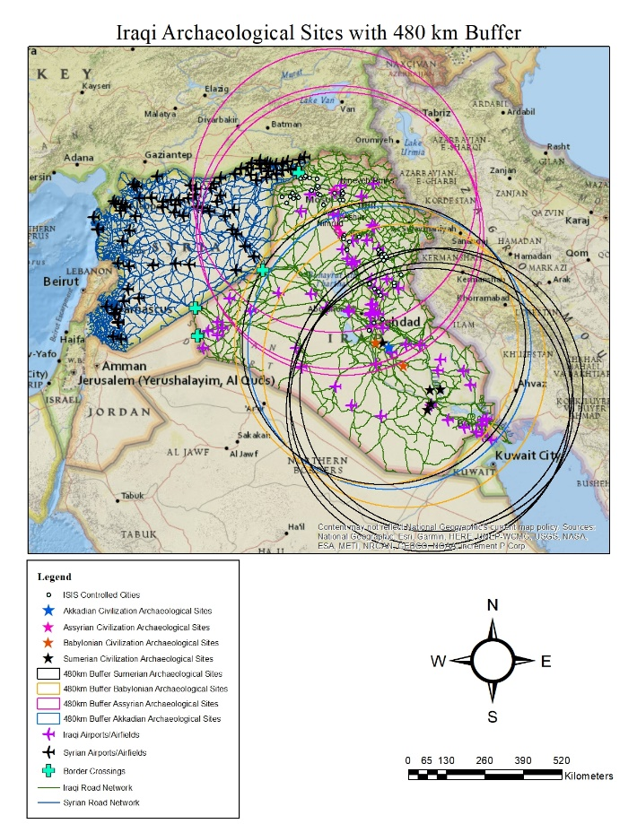**Scenario 3: Using the road networks within Iraq and Syria, where are the airports and/or seaports that could provide additional avenues of exporting looted artifacts.**

Analyses based on buffers run with both known vehicles employed by ISIS showed a startling range of possibilities, as both Iraq and Syria have an extensive network of airfields and airports that can be reached by either vehicle traveling along well-defined roads or less well-defined roads (Figure 2). Both vehicles have off-road capabilities that would allow artifacts to be taken to airfields within areas of ISIS control (Figure 6). This information, combined with the results of both Scenarios 1 and 2, provided me with a solid basis with which to address my research questions with greater confidence.

Figure 7: Map of Iraqi archaeological sites with 480 km buffers.

**Research Question 1: Can GIS software applications aid in estimating locations that insurgents or gangs of smugglers could transport stolen heritage artifacts to?**

The answer to this is undoubtedly yes. Maps made from various GIS layers of roads, airports, border crossings, and archaeological site locations show clearly how easy it is to not only access the extensive road network within the countries studied in this project, but to also reach various airfields, seaports, and locations that could be used for long term storage of illicit artifacts. Using Thiessen polygons proved useful in understanding the range of control of insurgent groups – in this case, ISIS in 2014 – while buffer analyses showed the viable range of transport of vehicles used by ISIS during this same time period. Of course, the limitation here is that the prediction area in question is enormous and requires more analysis, perhaps undertaken in future studies.

**Research Question 2: How useful are knowing the road networks in understanding the possible paths that stolen artifacts could take out of the country?**

Following the roads is undeniably one of the keys in tracking the paths that stolen antiquities travel from their destroyed heritage locations into the ether of the black market. Further analysis of the extensive network of roads with real time satellite imagery is a nearly impossible task but being able to determine which paths are more likely than others, by tracing the distances between airfields and archaeological sites, can narrow search areas and possibly provide a better avenue of tracking vehicles potentially carrying looted materials to their destinations.

**Research Question 3: How can understanding the vehicles used by insurgent groups aid in predicting possible exit routes?**

Understanding the utility of the vehicles at the disposal of insurgents and criminal gangs is another key in this equation. If we know what vehicles they are using, how far these vehicles can move, their capacity for moving artifacts, and their capabilities on both well-known and less maintained roads, we can then use GIS applications to understand their coverage ability. Further, we can take advantage of additional satellite imagery to watch for these types of vehicles moving along the roads leading from sites to airports, airfields, and locations for further storage that have been identified as most probable through the use of buffers, Thiessen polygons and Near function analysis.

While my original project had sought to predict sites at greater risk of looting to provide heritage professionals and interested governments with a tool to protect these at-risk locations, I feel that the current version of my project is of greater value. Given my naivete with predictive models, I originally believed that it could be a useful tool – something that, while not indisputable, could be, at the very least, valuable. Both professional advisement and research has indicated that predictive models are only as good as the information being fed into them and there is no guarantee that they are either viable or meaningful (Wheatley and Gillings 2002, p. 90-95). In the stead of creating a potentially weak predictive model, I chose to follow the roads, hoping they would aid in estimating the possible paths that smugglers, looters, and thieves could take to move their illicit goods into the eager hands of black-market dealers. I believe that the use of ArcGIS has allowed me to at least start on this path, though by no means complete it. More time and information, greater access to sensitive or classified data, and access to real time satellite imagery would be invaluable in furthering this research. While another daunting task, it is one that is undoubtedly valuable in the battle against the illicit antiquities trade.

**BIBLIOGRAPHY**

Brodie, Neil, and Colin Renfrew. 2005. “Looting and the World’s Archaeological Heritage: The

Inadequate Response.” *Annual Review of Anthropology* 34: 343-361.

Casana, Jesse. 2015. “Satellite imagery-based analysis of archeological looting in Syria.” *Near*

*Eastern Archaeology* 78: 142-152.

Daley, Jason. 2018. “After More Than 90 Years, Looted Mummy Parts Repatriated to Egypt.”

Smithsonian Magazine, website; accessed March 25, 2019. <https://www.smithsonianmag.com/smart-news/mummy-parts-repatriated-egypt-90-years-after-being-looted-180967760/>

Danti, Michael. 2015. “Ground-Based Observations of Cultural Heritage Incidents in Syria and

Iraq.” *Near Eastern Archaeology* 78 (3): 132-141.

Digital Globe. 2018. “DG_Human_Landscape_Syria_Airfields”. Esri ArcGIS Online

catalog, accessed February 28, 2019.

Esri ArcGIS Online Team. 2012. “Ancient Cities and Kingdoms in Iraq.” Esri ArcGIS Online

catalog, accessed January 25, 2019.

Illingworth, Andrew. 2018. “Russia ships rarely-seen military equipment to Syria amid ongoing

reinforcement operation.” Al-Masdar News.com; accessed March 25, 2019. <https://www.almasdarnews.com/article/pictures-russia-ships-rarely-seen-military-equipment-to-syria-amid-ongoing-reinforcement-operation/>

Leviev, Ruslan. 2016. “Russian vehicles transferred from Hmeymim airbase to Eastern Syria –

Conflict Intellegence Team.” Conflict Intelligence Team, website. <https://citeam.org/russian-vehicles-transferred-from-hmeymim-airbase-to-eastern-syria/?lang=en>

Malcom, Nance. 2016. Defeating ISIS: Who They Are, How They Fight, What They Believe.

New York, NY: Simon and Schuster.

Meskell, Lynn. 2014. “States of Conservation: Protection, Politics, and Pacting within

UNESCO’s World Heritage Committee.” *Anthropological Quarterly* 87 (1): 217-243.

Mrhoades.DCGSMARINECORPS. 2018. “IraqRoads”. Esri ArcGIS Online catalog, accessed January 25, 2019.

Nesforum. 2017. “Syria Roads”. Esri ArcGIS Online Catalog, accessed February 20, 2019.

Parcak, Sarah. 2015. “Archaeological Looting in Egypt: A Geospatial View (Case Studies from

Saqqara, Lisht, and el Hibeh).” *Near Eastern Archaeology* 78 (3): 196-203.

Oshkosh Defense. 2014. “Medium Tactical Vehicle Replacement, MTVR.” Oshkosh Defense

website. Accessed March 28, 2019. <https://oshkoshdefense.com/wp-content/uploads/2018/12/12705_MTVR_bro_single_LoRes_3.2014.pdf>

Sarah7600.fed. 2014. “Control_in_Iraq”. Esri ArcGIS Online catalog, accessed January 25,

2019.

Sarah7600.fed. 2014. “Iraq_Airport_Airbase”. Esri ArcGIS Online catalog, accessed February

28, 2019.

Sarah7600.fed. 2014. “Iraq_Borders”. Esri ArcGIS Online catalog, accessed January 25, 2019.

Sorensen, Marie Louise Stig and Dacia Viejo-Rose. 2015. War and Cultural Heritage –

Biographies of Place. New York, NY: Cambridge University Press.

Stein, Gil J. 2015. “The War-Ravaged Cultural Heritage of Afghanistan: An Overview of

Projects of Assessment, Mitigation, and Preservation.” *Near Eastern Archaeology* 78 (3): 187-195.

Stone, Elizabeth C. 2015. “An Update on the Looting of Archaeological Sites in Iraq.” *Near*

*Eastern Archaeology* 78 (3): 178-186.

Stone, Peter G. 2011. Cultural Heritage, Ethics, and the Military. Rochester, NY: The Boydell

Press.

Tchoukanski, Ianko. 2019. “Build Thiessen Polygons.” Ian-Ko.com, website. Accessed March

20, 2019. <https://www.ian-ko.com/ET_GeoWizards/UserGuide/thiessenPolygons.htm>

Terrill, W. Andrew. 2017. Antiquities Destruction and Illicit Sales as Sources of ISIS Funding

and Propaganda. Carlisle, PA: U.S. Army War College.

“Ural-4320 General Utility Truck.” Military-Today.com, website. Accessed March 25, 2019.

<http://www.military-today.com/trucks/ural_4320.htm>

Viejo-Rose D., Sørensen M.L.S. (2015) Cultural Heritage and Armed Conflict: New Questions

for an Old Relationship. In: Waterton E., Watson S. (eds) The Palgrave Handbook of Contemporary Heritage Research. Palgrave Macmillan, London.

Wheatley, David and Mark Gillings. 2002. Spatial Technology and Archaeology, The

Archaeological Applications of GIS. New York, NY: Taylor & Francis.

Woodrow Wilson International Center for Scholars. 2019. “Timeline: the Rise, Spread and Fall

of the Islamic State”. Wilsoncenter.org, accessed April 1, 2019. <https://www.wilsoncenter.org/article/timeline-the-rise-spread-and-fall-the-islamic-state>

Maps throughout this project were created using ArcGIS® software by Esri. ArcGIS® and ArcMap™ are the intellectual property of Esri and are used herein under license. Copyright © Esri. All rights reserved. For more information about Esri® software, please visit [www.esri.com](http://www.esri.com).